**Project Design Phase-II**

**Data Flow Diagram & User Stories**

|  |  |
| --- | --- |
| Date | JUNE 19 2025 |
| Team ID | LTVIP2025TMID32436 |
| Project Name | TRAFFIC TELLIGENCE |
| Maximum Marks | 4 Marks |

**Data Flow Diagrams:**

A Data Flow Diagram (DFD) is a traditional visual representation of the information flows within a system. A neat and clear DFD can depict the right amount of the system requirement graphically. It shows how data enters and leaves the system, what changes the information, and where data is stored.

**Example:**

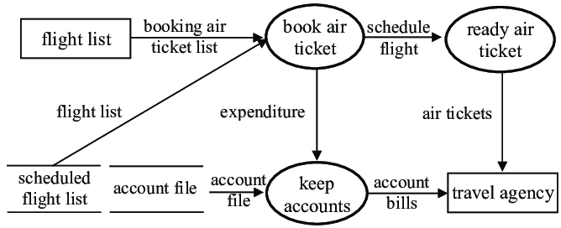

**User Stories**

Use the below template to list all the user stories for the product.

| **User Type** | **Functional Requirement (Epic)** | **User Story Number** | **User Story / Task** | **Acceptance criteria** | **Priority** | **Release** |
| --- | --- | --- | --- | --- | --- | --- |
| passenger |  | USN-1 | As an educator, I can book my flight ticket | I can create an account easily | High | Sprint-1 |
|  |  | USN-2 | As an educator, I can know when my flight comes | I can create my ticket by my own | High | Sprint-1 |
|  |  | USN-3 | As an educator, I see videosif I don’t know how to book my ticket | I can alsoknow which is best app | High | Sprint-2 |
|  |  |  |  |  |  |  |
| Learner |  | USN-1 | As a learner, I can find latest technology courses | I can easily find latest courses | High | Sprint 1 |
|  |  | USN-2 | As a learner, I should be able to learn from the comfort of my home | I can easily learn any course sitting in my home | High | Sprint 1 |
|  |  | USN-3 | As a learner, I should be able to learn courses in any regional language | I can learn a course in any language I want | Low | Sprint 2 |
|  |  |  |  |  |  |  |
|  |  |  |  |  |  |  |
|  |  |  |  |  |  |  |

